
Satellite Internet 101 — Connecting Homes Everywhere

Satellite Internet 101: Connecting the Unconnected
There’s exactly one type of internet connection that can reach literally any address in the United States — including the middle of a wheat field, the top of a mountain, or a cabin three hours from the nearest town. That’s satellite internet, and for millions of rural and remote households, it’s not a backup option; it’s the only option. Here’s how it works, what’s genuinely improved in recent years, and where it still falls short.

How Satellite Internet Works
Satellite internet skips ground infrastructure entirely. A small dish installed at your home sends and receives signal directly to a satellite orbiting roughly 22,000 miles above Earth, which relays your connection back down to a ground station and onto the broader internet. Because a single satellite can cover an enormous geographic area from that altitude, satellite internet can reach addresses that no fiber line, cable network, or cell tower ever will.
This is the entire appeal in one sentence: if nothing else reaches your home, satellite almost certainly does.
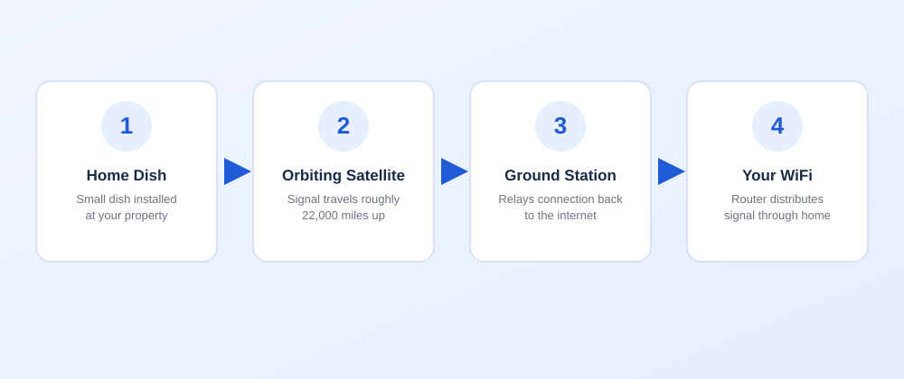
How satellite internet works — from home dish to orbiting satellite to ground station to your WiFi

The Trade-Off Nobody Should Hide From You: Latency
Here’s the part that matters most to understand before signing up. That 22,000-mile round trip to orbit and back takes time — physically, there’s no way around it. Traditional satellite internet has noticeably higher latency than any other connection type, typically in the 500–800 millisecond range, compared to fiber’s sub-10ms response time.
What this means in practice: web pages still load, streaming still works fine, video calls are generally usable (with a slight delay you’ll notice but adjust to), and browsing feels normal. What it’s not well suited for is anything requiring split-second responsiveness — competitive online gaming being the clearest example, where that delay is the difference between landing a shot and missing it.
If your household’s needs are streaming, browsing, email, video calls, and general use, satellite handles all of that comfortably. If competitive gaming is a priority, it’s worth being honest about that limitation upfront.

Speeds Have Genuinely Improved
Older satellite internet had a reputation for being slow, and that reputation isn’t unfair to where the technology used to be. That’s changed substantially. Viasat, one of the leading satellite providers, now offers plans with download speeds up to 150 Mbps — fast enough for HD and even 4K streaming, multiple connected devices, and normal household use without the constant buffering older satellite customers remember.
Viasat’s plans also don’t impose a hard data cutoff the way some satellite services historically did. Instead, speeds may be reduced during network congestion after you’ve used your plan’s priority data allowance, but you stay connected rather than being completely cut off — a meaningful improvement in how the service actually behaves month to month.

What Satellite Internet Costs
Viasat’s Essentials plan typically starts with a promotional rate around $39.99/month for the first few months before settling to a standard rate, with the Unleashed plan — offering unlimited data and the higher speed tier — starting similarly before adjusting after the promotional period. Equipment rental runs an additional monthly fee on top of the plan price, and Essentials plans typically require a 12-month service agreement, while Unleashed plans are contract-free.
One detail worth knowing about going in: always ask about the post-promotional rate, not just the introductory price, so there are no surprises a few months in. Free professional installation is standard, which helps offset the equipment cost somewhat, since self-installation generally isn’t an option with satellite — dish alignment needs to be precise.

Satellite vs. Everything Else
 | Satellite | Fiber | Cable | 5G Home
Availability | Anywhere in the US | Limited, expanding | Wide, but not universal | Depends on tower coverage
Latency | Highest (500-800ms) | Lowest | Moderate | Low-moderate
Max speed | Up to 150 Mbps | Up to 8 Gbps | Up to 2 Gbps | 100-300 Mbps
Installation | Professional, dish required | Professional | Often self-install | Self-install
Best for | No other options exist | Heavy users, gaming | Budget, wide availability | Renters, simple setup
If you have any access to fiber, cable, or 5G Home Internet at your address, those will generally outperform satellite on speed and especially latency. Satellite’s real value is being the connection that exists when nothing else does.

Who Satellite Internet Is Actually Built For
Rural and remote homes — farms, ranches, and properties well outside the range of cable or fiber buildouts, where satellite is often genuinely the only wired-equivalent option available.
Vacation homes and cabins — seasonal properties in areas without ground infrastructure still benefit from reliable connectivity, and Viasat even offers a reduced-cost “hibernation” plan for properties used only part of the year.
New construction in undeveloped areas — if you’re building somewhere fiber and cable haven’t reached yet and may not for years, satellite gets you connected immediately rather than waiting on a buildout timeline you don’t control.

The Bottom Line
Satellite internet isn’t trying to compete with fiber on speed or latency — it’s solving a completely different problem: universal availability. For the millions of households outside the reach of wired infrastructure, modern satellite service (with real speeds up to 150 Mbps and no hard data cutoffs) is a dramatically better experience than the technology’s older reputation suggests, even if the latency trade-off remains real.
Wondering if satellite is your best option, or if something faster has actually reached your address? Call (888) 841-5332 to find out, or see full Viasat plans and current pricing here.

